SIMATS ENGINEERING
ASSESSMENT TOOL 1

COURSE NAME: CSA16 COURSE CODE: Data Warehousing and Data Mining

COURSE OUTCOME COVERED

CO3: Evaluate the effectiveness of classification techniques on real-time data for accurate prediction, enabling informed decision-making. (BL3,BL4,BL5)
Assessment Tool Weightage: 50%

Code of Conduct:

I K Ram Charan Teja (192371050) (Name / Reg No) certify that this submission is my original work and that I have adhered to the guidelines specified for this assessment.
I understand that any violation of academic integrity rules will result in disciplinary action.

Signature of the student:


QUESTIONS: 5 Total Marks:50

Children of three ages are asked to indicate their preference for three photographs of adults.
Do the data suggest that there is a significant relationship between age and photograph
preference? What is wrong with this study?
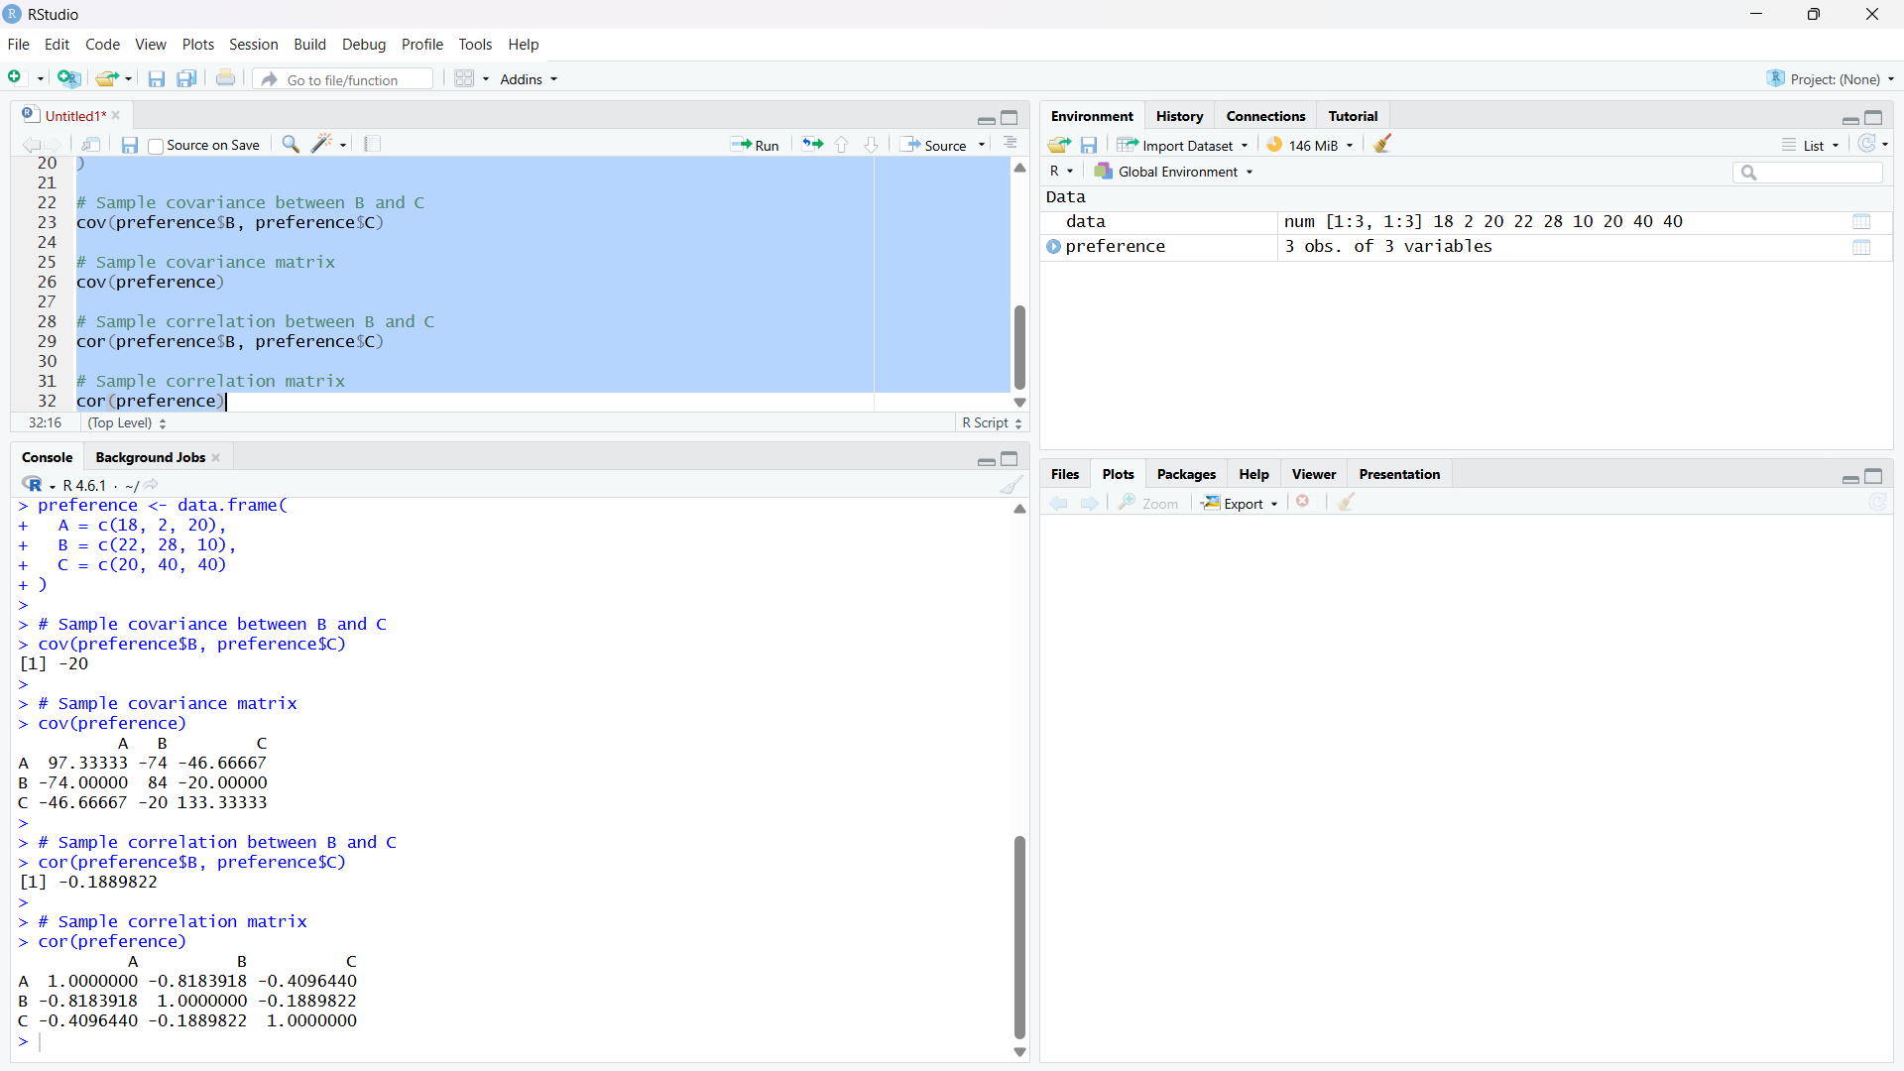
2. Assume the Tennis coach wants to determine if any of his team players are scoring
outliers. To visualize the distribution of points scored by his players, then how can he
decide to develop the box plot?
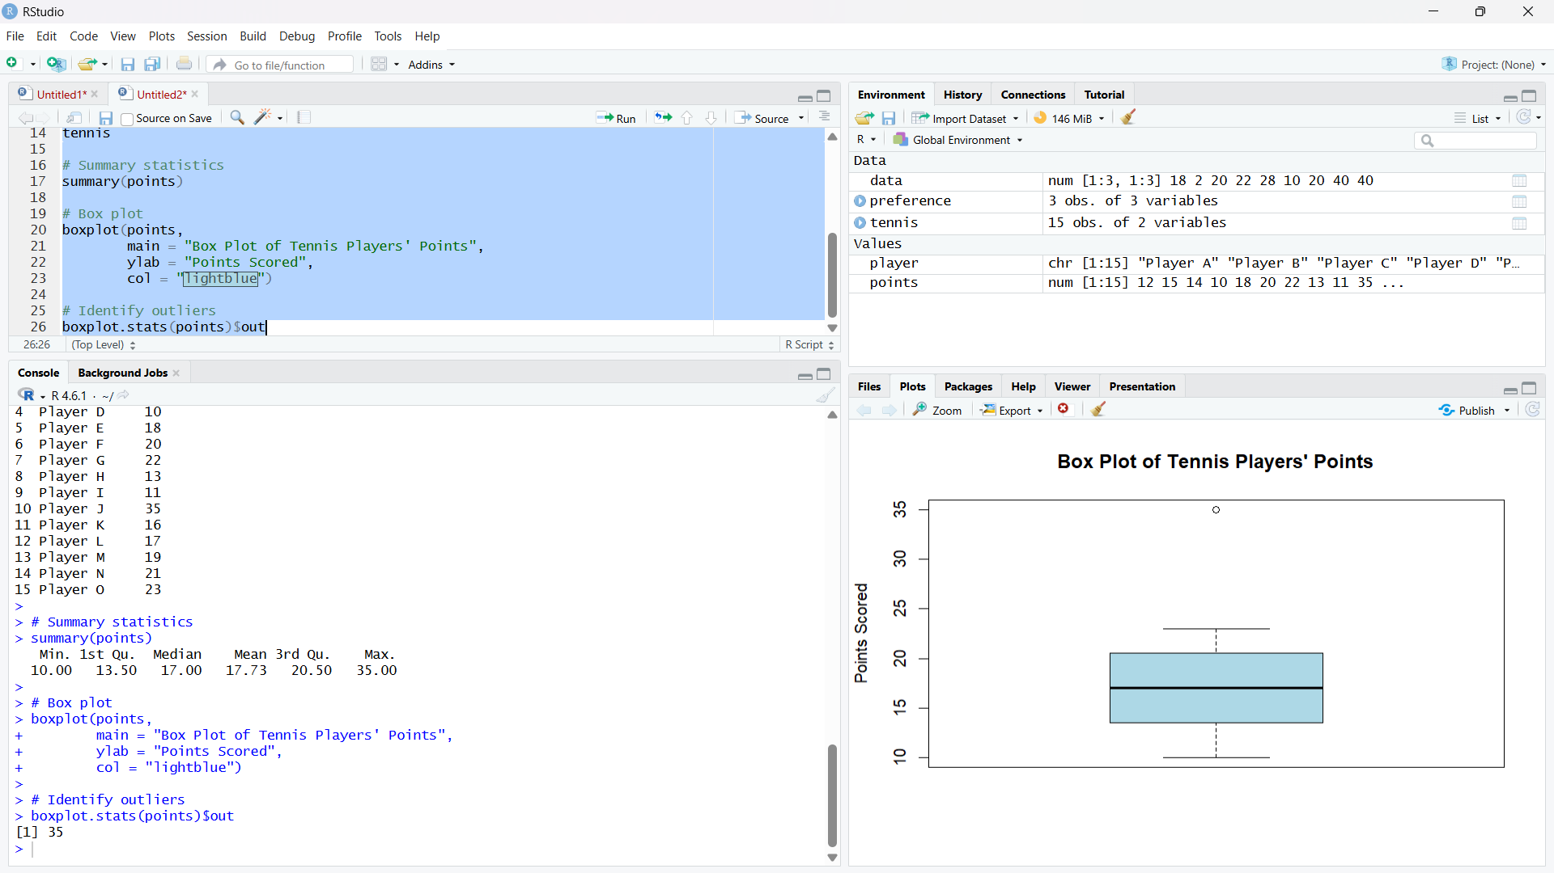

3. A bank wants to decide whether to approve a loan based on customer attributes like:
• Age
• Income
• Employment Status
• Credit Score
Using historical data, build a Decision Tree classifier to predict Loan Approval (Yes/No).
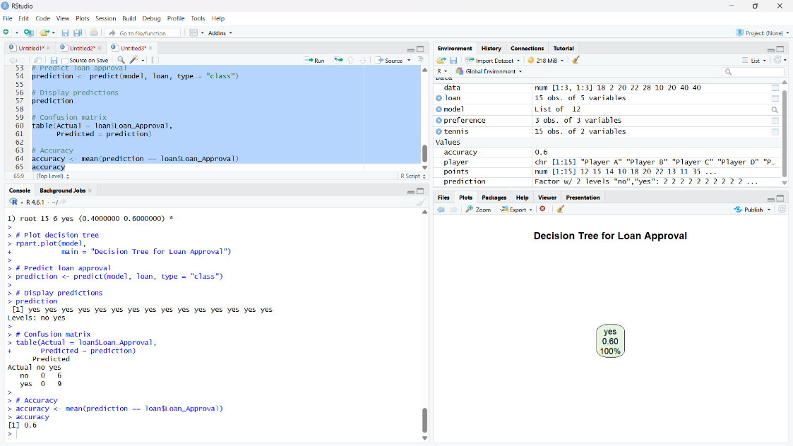
4. Two Maths teachers are comparing how their Year 9 classes performed in the end of year
exams. Their results are as follows:
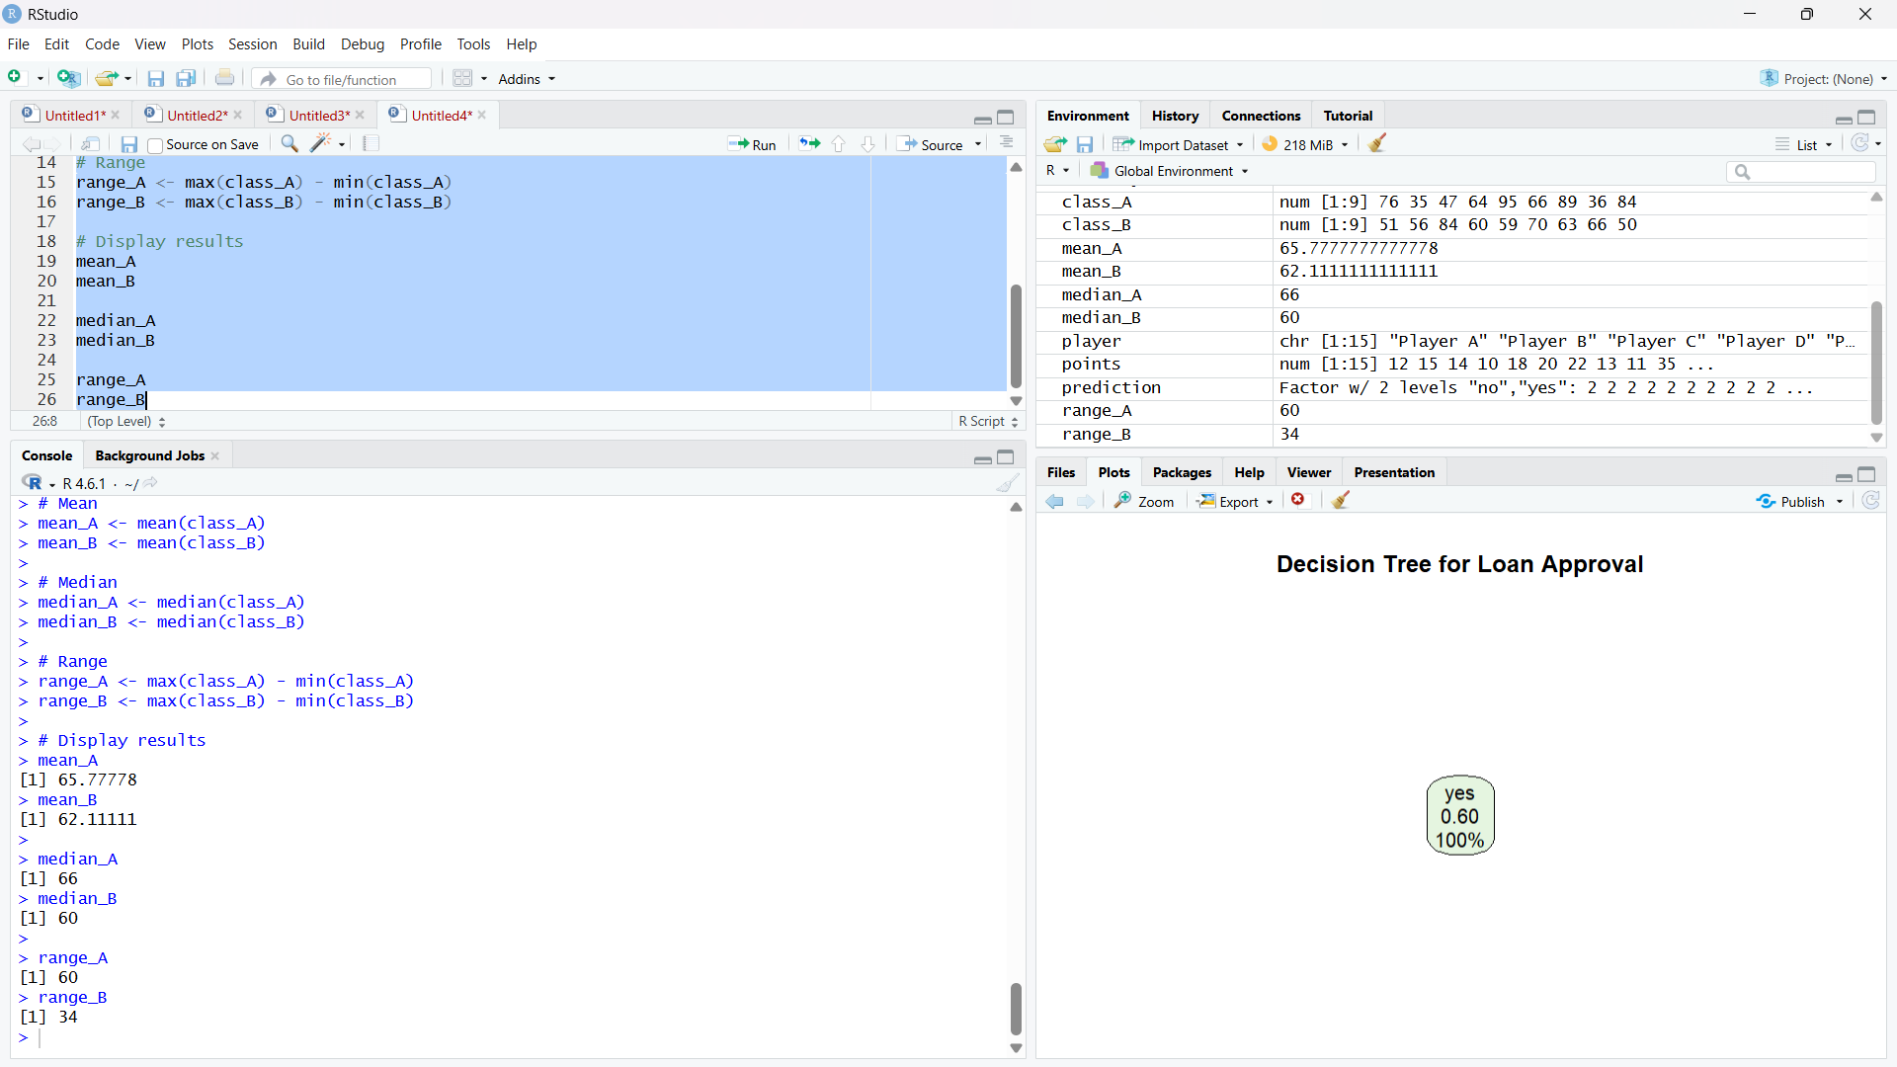

5. Suppose that a hospital tested the age and body fat data for 18 randomly selected adults
with the following results: 